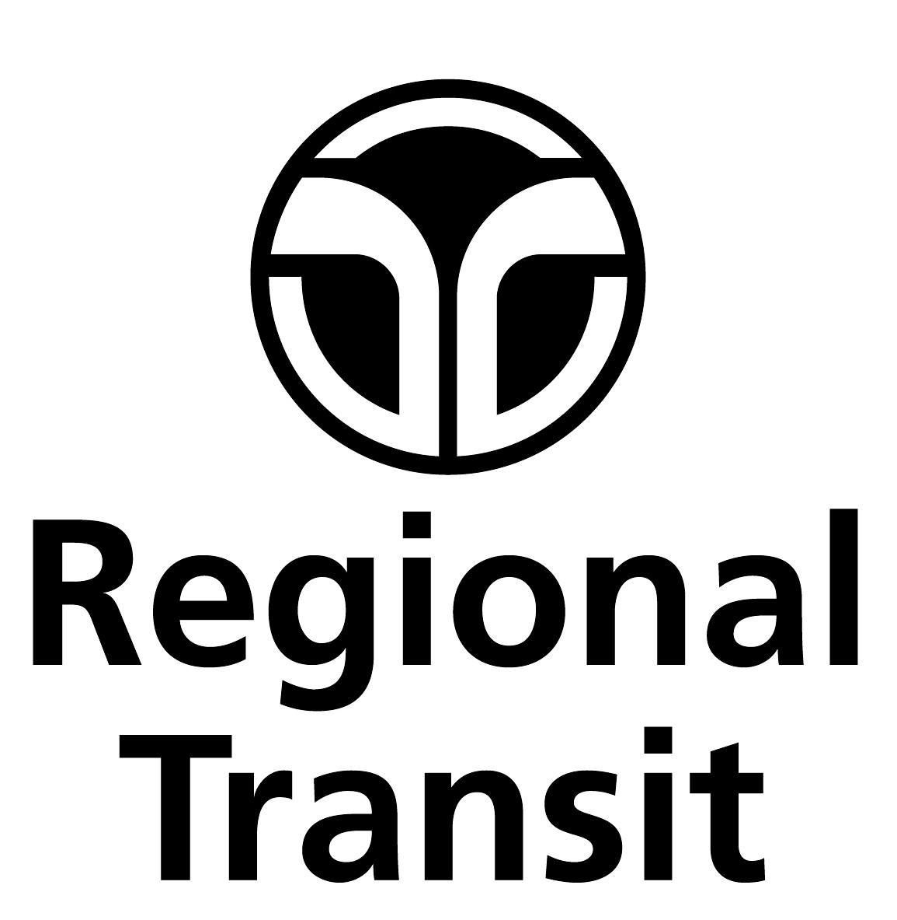 |  | SACRAMENTO REGIONAL TRANSIT DISTRICT  MOBILITY ADVISORY COUNCIL  N O T I C E

NOTICE OF MEETING CANCELLATION

The Sacramento Regional Transit District Mobility Advisory Council (MAC) meeting scheduled for
July 9, 2020 has been cancelled.

Janice Labrado, Director, Accessible Services

(916) 556-0140

OR

Andrea Williams-Garcia, Administrative Assistant II
(916) 556-0191

FAX (916) 455-3924 TDD (916) 557-4686

