|  |  |
| --- | --- |
|  |  |
|  | **Overall**  **Disadvantaged Business Enterprise**  **Goal and Methodology for FFY 2024-2026**  **October 1, 2023 to**  **September 30, 2026** |

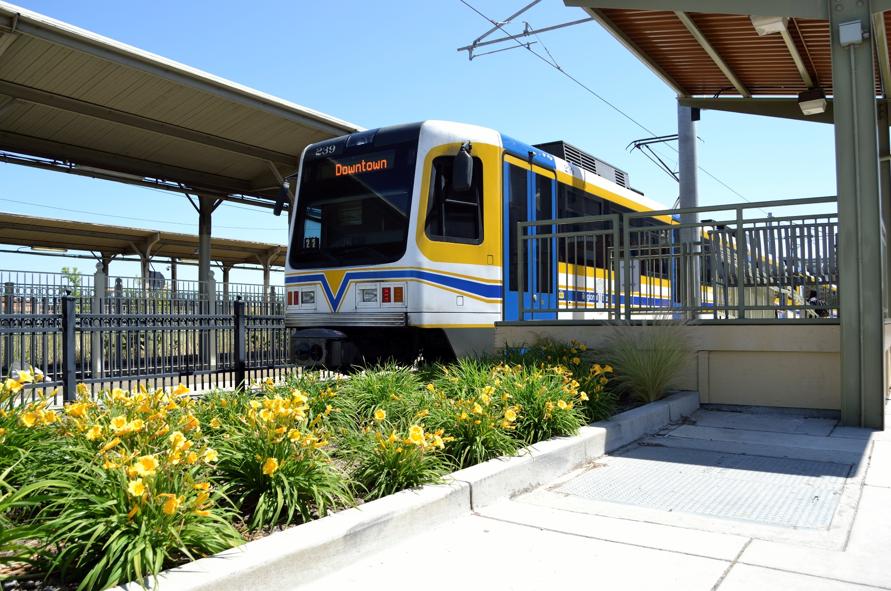

**Sacramento**

**Regional Transit District**

1. **INTRODUCTION**

Sacramento Regional Transit District (SacRT) is committed to promoting diversity, equity, and inclusion in all aspects of our operations. The goal of SacRT’s DBE Program, in compliance with 49 CFR Part 26, is to ensure nondiscrimination in the award and administration of federally-funded contracts and to create opportunities for certified Disadvantaged Business Enterprises (DBEs). Our aim is to enhance the participation of DBEs in our contracting and procurement processes, ultimately promoting diversity and economic growth within our organization and the communities we serve, while fostering an inclusive and equitable environment.

This DBE Overall Goal document reflects SacRT's commitment to complying with the requirements of 49 CFR Part 26 while promoting diversity, equity, and inclusion. By implementing these objectives, strategies, and actions, SacRT will work towards creating a level playing field for all businesses and enhancing the participation of certified DBEs in our contracting and procurement processes. We recognize that achieving these goals requires ongoing effort, monitoring, and improvement. Together, we can contribute to the economic growth and inclusivity of our organization and the communities we serve.

1. **EXECUTIVE SUMMARY**

SacRT is required to establish an overall triennial Disadvantaged Business Enterprise Goal (Triennial Goal) for its federally-assisted contracting activity and submit the applicable methodology to the Federal Transit Administration (FTA) for approval. Disadvantaged Business Enterprise (DBE) goals are set and managed on a Federal Fiscal Year (FFY) basis. This document presents SacRT’s Triennial Goal for FFY 2024 – 2026 as well as the methodology used to establish the goal. SacRT’s methodology follows a two-step process, consistent with the requirements contained in 49 CFR Part 26.45:

1. Determine a base figure for the relative availability of DBEs

2. Adjust the base figure, if necessary

SacRT staff reviewed its contracting activities and DBE utilization for the period FFYs 2020- 2023 and proposes a **Triennial Overall DBE Goal for FFY 2024 – 2026 of** **2.26%** for its federally-assisted transit contracts (exclusive of any FTA funds to be used for the purchase of transit vehicles), which is planned to be attained using race- and gender-neutral (RN) means. However, should SacRT determine that it is not on track to meet the DBE goal in any given FFY, SacRT may choose to use RC methodology pursuant to the goal setting requirements specified in 49 CFR Part 26.51(f).

1. **STEP 1: DETERMINATION OF BASE FIGURE FOR THE RELATIVE AVAILABILITY OF DBE FIRMS**

**STEP 1, Part A: Determination of SacRT’s Relevant Geographical Market Area**

49 C.F.R. Part 26 requires that SacRT set goals consistent with its own contracting circumstances. To calculate availability, the relevant geographical market area for SacRT must first be determined to set overall goals based on demonstrable evidence of the relative availability of ready, willing, and able DBEs in the area in which the substantial majority of the contractors and subcontractors with which SacRT does business are located and the area in which SacRT spends the majority of its Federally-assisted contracting dollars.

Federally-assisted Contracts and Purchase Orders awarded during the time period between October 1, 2020 and September 30, 2022 were analyzed to determine SacRT’s relevant geographical market area. The awards consist of various service and construction contracts and supply and material purchases. The awards were identified by funding source, prime contractor, and prime contractor location (grouped by county).

**Table 1: Relevant Geographical Market Area**



Data was compiled from SacRT’s PlanetBids Contract Management database and SacRT’s SAP enterprise management software system. Analysis showed that 62.97% of SacRT’s Federally-assisted awards were to firms located in California. Of the California awards, 43.10% were to firms located in the **Counties of Sacramento and Placer**, constituting 68.45% of the total California award commitments; these two counties will be used as SacRT’s relevant market area for this goal setting period.

**STEP 1, Part B: Projected FTA-Funded Contracting Activity for FFY 2024-2026**

To calculate the Step 1 Base Figure, SacRT staff compiled a list of Federally-assisted Contracts that are anticipated to be awarded in FFY 2024-2026.

**Table 2: Anticipated Contracts**



Dos Rios Light Rail Station: SacRT is partnering with SHRA to design and construct a light rail station on the NE corridor between North B Street and Richards Blvd. on North 12th Street in downtown Sacramento. The project requires track realignment, signaling modifications, and system upgrades to allow for the construction of the new light rail station. 1,400 feet of double track and special trackwork need to be reconstructed to shift the alignment out of N. 12th Street to allow for the new platforms.

Watt/I-80 Transit Center Improvements: SacRT is working to enhance the Watt/I-80 Transit Center, including strategies to improve visibility, natural surveillance, and regular positive activity, such as redesigning stairwell and elevator structures to be more open and accessible; add lighting, construct a well-defined plaza area, and remove and restrict access to hiding spaces; and invest in further site maintenance. Additional infrastructure improvements to Watt Avenue and bus stop amenities will enhance pedestrian, bicycle, and drop-off vehicle access to the Transit Center, as well as user-friendliness and comfort, which were identified as major priorities by current riders and desirable for potential future riders.

Light Rail Low-Floor Station Conversions: As SacRT transitions to a low-floor light rail fleet, SacRT must modify 48 light rail station platforms to accommodate the new low-floor vehicles. Scope includes design and construction to create a differential between the top platform elevation and the top of rail to allow level boarding. The project is currently planned in 4 phases, with phase 1 construction currently underway.

Horn Light Rail Station: SacRT is partnering with the City of Rancho Cordova to plan, design, and construct a light rail station near Horn Road and Folsom Boulevard. Constructing the station will require relocation of adjacent freight track and a design that balances costs with community expectations. This project will provide additional access for SacRT riders, and it will bridge the distance between the Butterfield and Mather Field Stations. In addition it will create a pedestrian/transit-oriented hub; help implement transit oriented development along Folsom Boulevard; provide convenient connection to civic amenities, including the nearby library and the County social services office; and support the Folsom Boulevard Complete Streets program that encourages pedestrian and bicycle travel along Folsom Boulevard.

Sacramento Valley Light Rail Station (SVS) Relocation: SacRT plans to relocate the existing temporary light rail station on H Street, west of 5th Street to a north-south axis configuration west of 5th Street. This project supports railyard development; it will provide service for the new State Department of General Services building and the proposed major league soccer stadium, and it is included in the City of Sacramento’s SVS Master Plan. The project will also support the Downtown Riverfront Streetcar Project and the Green Line light rail extension.

**STEP 1, Part C: Calculating the Base Figure**

Pursuant to 49 CFR 26.45(c), to determine the baseline figure for its FFY 2024-2026 DBE Goal, SacRT used the most recent data available in the Census Bureau’s County Business Pattern Database (CBP) and the California United Certification Program (CUCP) DBE Directory, to determine the percentage of ready, willing, and able DBEs in SacRT’s market area.

SacRT has made preliminary assumptions regarding which six-digit North American Industry Classification System (NAICS) Codes will have relevance to the contracting opportunities for upcoming projects receiving FTA funding in the next three federal fiscal years. For the major construction projects, the Prime NAICS code 237310 “Highway, Street, and Bridge Construction” was not included in this analysis, therefore only the subcontracting opportunities for those major projects are included in the calculations.

**Table 2: Relative Base Figure**



*Relative Base Figure =()*

SacRT believes this relative base figure calculation does not accurately quantify the percentage of available DBEs, as it assumes that every DBE has an equal opportunity and equal weight to perform on SacRT’s contracts. However, in the practical application, not all DBEs have equal opportunity for participation, as opportunity is dependent on the amount of dollars spent in each NAICS code. Therefore, to reflect the relative availability of DBE firms more accurately, as recommended by U.S. DOT, SacRT performed a weighted calculation of availability. This calculation is based on an estimation of work types for SacRT’s future projects with FTA-funded expenditures, classified by NAICS code.

**Table 3: Weighted Base Figure**



*Weighted Base Figure = [(%Projected Expenditures by NAICS Code Expense Category)()]*

The percentage of estimated contract dollars categorized by NAICS code multiplied by the relative DBE availability percentage for each NAICS code yields a weighted base figure of 1.66%.

1. **STEP 2: BASE FIGURE ADJUSTMENT DETERMINATION**

49 C.F.R. Section 26.45 Part 26 requires an examination of available relevant evidence to determine what additional adjustment to the Base Figure is needed, if any, to narrowly tailor the Base Figure to SacRT's marketplace and establish the overall goal.

**STEP 2, Part A: Current Capacity of DBEs Measured by Actual Attainments**

SacRT considered the capacity of DBEs to perform work as measured by the median past participation of DBEs on SacRT's DOT-assisted contracts for two sets of FFYs for comparison purposes: 1) FFYs 2018 through 2022, and 2) FFYs 2020 through 2022. Typically, the median would be established using only the previous three-year period; however, because of the affects of COVID-19 pandemic in 2020 and 2021, SacRT determined that examination of both the last 3 years and the last 5 years would yield a more median value for this analysis. However, both sets of data yielded the same median, as shown below. Data was taken from FTA-approved Semi-Annual Uniform Reports of DBE Awards/Commitments. Table 5 summarizes the findings.

**Table 5: Median Past Participation of DBEs**



Because the FTA-assisted contracts that SacRT anticipates awarding for the upcoming period are substantially similar to those awarded during the prior goal-setting periods, it is appropriate to use the median past participation methodology to make an adjustment to the base figure. In this case, application of the median results in an upward adjustment of the base figure. To arrive at an overall goal, SacRT averaged the Step 1 weighted base figure 1.59% with the Step 2 past participation median accomplishment of 2.87% to further refine SacRT’s goal to arrive at an **Overall DBE Goal of 2.26%.**



*(Base Figure + Median Past Participation) / 2 = Adjusted Base Figure*

**Public Review and Comments**

SacRT will accept public comments for a 30-day period beginning June 12, 2023 and ending July 12, 2023.

Please send comments to:

Jessica Bennick Shevlin

SacRT DBE Liaison Officer

[jshevlin@sacrt.com](mailto:jshevlin@sacrt.com)