March 25, 2022

To Our Valued Customers:

We sincerely apologize for the operational performance that you may have experienced with SacRT GO Paratransit Services recently. We are seeing an increased demand in paratransit service as people are feeling more comfortable to travel more, combined with a driver shortage, has caused a unique situation.

SacRT has processes in place to address the recent delays in service. We are actively recruiting drivers and holding in-person hiring events, even offering $2,000 sign on bonuses and other incentives. We had a hiring event on March 22, 2022, and our next hiring event is March 30, 2022. Further, we currently have 14 operators in training with three expected to graduate in the coming week.

Additionally, to ensure the best service possible for our customers, SacRT is partnering with an Adaptive Transportation Network Company called UZURV to provide additional support for SacRT GO customers starting Tuesday, April 19, 2022. This company will support up to 25% of SacRT GO trips and help prevent delays in service.

UZURV independent contractor drivers will operate regular passenger vehicles to provide SacRT GO customers door-to-door service. Vehicles are marked with a UZURV sticker decal on the front window and a SacRT GO magnet on the passenger side door. Please look out for additional information.

If you have any questions, please don’t hesitate to contact us at (916) 321-BUSS (2877), select option #2.

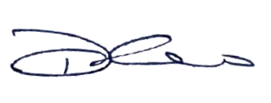Sincerely,

Dan Thao
Director, Community and Contract Bus Services

